CloudExify Cybersecurity Internship
Project 02 Report

Cryptography and Password Security

- Prepared By Javeria Khan

- Reg. No CX-INT-2026-CYB-0525

- Program BS Computer Science

- University University of Technology
Nowshera

- Email jiya04229@gmail.com

- Internship Organization CloudExify

- Table of Contents

Sr. No. | Contents | Page No.
01 | Cover Page | 01
02 | Table of Contents | 02
03 | Introduction | 04
04 | Objectives | 05
05 | Tools Used | 05
06 | Environment Setup | 06
08 | Cryptography Library Installation | 06
09 | Bcrypt Library Verification | 07
10 | Project Folder Structure | 08
11 | Password Hashing (bcrypt) | 09
12 | SHA-256 vs bcrypt Comparison | 12
14 | Fernet Encryption & Wrong Key Scenario | 14
15 | Secure Login System | 19
16 | HTTPS & SSL/TLS | 22
17 | Professional Testing Table | 26
18 | Security Best Practices | 27
19 | Challenges Faced | 28
20 | Learning Outcomes | 28
21 | Conclusion | 29

Acknowledgment
I would like to express my sincere gratitude to CloudExify for providing me with the opportunity to complete this cybersecurity project as part of the Cybersecurity Internship Program – Month 1.
I am thankful for the guidance, learning resources, and practical tasks that helped me develop a better understanding of cryptography, password security, hashing, encryption, secure authentication, and HTTPS/SSL/TLS concepts.
I also appreciate the support and resources that enabled me to perform practical implementations using Python, bcrypt, SHA-256, and Fernet encryption. Completing this project enhanced my technical knowledge and provided valuable hands-on experience in applying cybersecurity principles.
Finally, I would like to thank everyone who contributed directly or indirectly to the successful completion of this project. This experience has strengthened my interest in cybersecurity and encouraged me to continue improving my technical and problem-solving skills.

Introduction
In today's digital world, protecting sensitive information has become one of the most important aspects of cybersecurity. Every day, users share personal data such as passwords, banking information, and confidential documents over the internet. If this information is not properly protected, it can be stolen or misused by attackers.
Cryptography is the science of securing information by converting readable data into an unreadable format that can only be accessed by authorized users. It plays a vital role in maintaining the confidentiality, integrity, and authenticity of digital information. Password security is another essential component of cybersecurity, as weak password storage methods can lead to data breaches and unauthorized access.
This project focuses on implementing secure password protection using the bcrypt hashing algorithm, comparing it with SHA-256, performing secure data encryption and decryption using Fernet, and developing a secure user authentication system in Python. It also explores the role of HTTPS and SSL/TLS in protecting data transmitted over the internet. Through this practical implementation, the project demonstrates modern cybersecurity techniques and industry-recommended security practices.

Objectives
The main objectives of this project are:
- To understand the fundamental concepts of cryptography and password security.
- To implement secure password hashing using the bcrypt algorithm.
- To compare the security features of SHA-256 and bcrypt.
- To perform secure data encryption and decryption using the Fernet encryption algorithm.
- To develop a secure user authentication system with registration and login functionality.
- To securely store user credentials using hashed passwords instead of plain text.
- To understand the importance of HTTPS and SSL/TLS for secure communication.
- To apply cybersecurity best practices in a practical Python-based project.
- To improve programming, debugging, and secure coding skills through hands-on implementation.

Tools Used
Tool / Technology | Purpose
Python 3.x | Programming language used to develop the project.
Visual Studio Code (VS Code) | Source code editor used for writing and debugging Python code.
Bcrypt | Used to securely hash user passwords with automatic salting.
Hashlib | Used to generate SHA-256 hashes for comparison purposes.
cryptography (Fernet) | Used to encrypt and decrypt sensitive data securely.
JSON (users.json) | Used to store user credentials in a structured format.
Windows Command Prompt / PowerShell | Used to execute Python programs and verify outputs.
Google Chrome | Used to verify HTTPS connections and SSL/TLS certificates.
Git & GitHub | Used for version control, source code management, and project submission.

Environment Setup

Purpose
To prepare a secure and reliable development environment for implementing the Cryptography and Password Security project.

Objective
To install and configure the required software, Python libraries, and project files necessary for developing, testing, and executing the cybersecurity application.

Description
Before starting the project, the development environment was configured using Python 3.x and Visual Studio Code (VS Code). The required Python libraries, including cryptography and bcrypt, were installed and verified using the pip package manager. After successfully installing the required dependencies, the project files were organized in a dedicated project folder to ensure proper file management and smooth execution of the application.

Result
The development environment was successfully configured. All required tools, libraries, and project files were properly installed and organized, allowing the project to run without any dependency-related issues.

Cryptography Library Installation

Screen shot

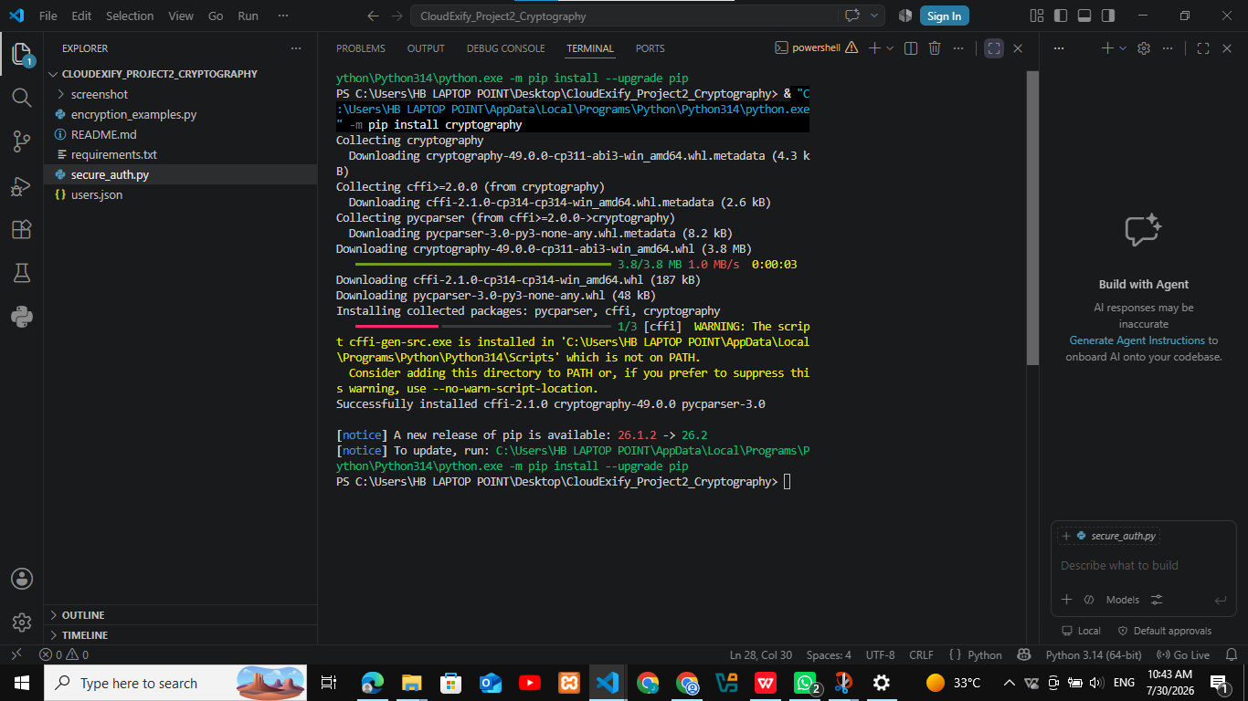
- Purpose:
To verify the successful installation of the cryptography library required for data encryption and decryption
- Objective:
To ensure that the cryptography package is correctly installed and ready for use in the project.
- Description:
The terminal output shows the successful installation of the cryptography library using the Python package manager (pip). This library is used to implement Fernet encryption for protecting sensitive information.
- Result:
The cryptography library was successfully installed, and the environment was prepared for implementing encryption features.

Bcrypt Library Verification

Screen shot
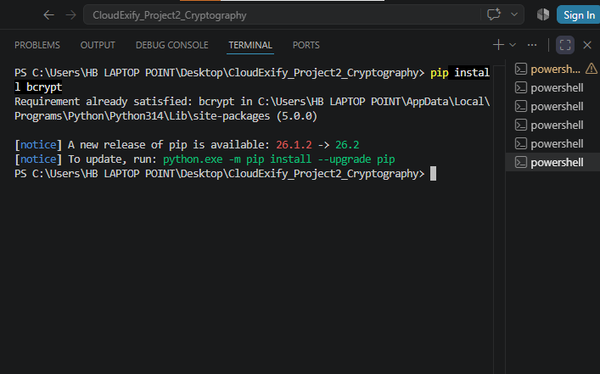
- Purpose:
To verify that the bcrypt library is installed and available for secure password hashing.
- Objective:
To ensure that the bcrypt package is ready to implement password hashing and user authentication.
- Description:
The terminal output confirms that the bcrypt library is already installed in the Python environment. This means the package is available and can be used to securely hash and verify user passwords.
- Result:
The bcrypt library was successfully verified and is ready for secure password hashing operations.

Project Folder Structure

Screen shot

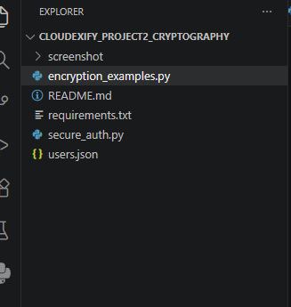
- Purpose:
To present the organized structure of the project files.
- Objective:
To verify that all required project files are properly arranged before implementation and submission.
- Description:
The Project Explorer displays all essential project files, including Python source code files, README.md, requirements.txt, users.json, and the screenshots folder. A well-organized project structure improves readability, maintenance, and project management.
- Result:
All project files were successfully organized in a structured directory, making the project easy to execute, maintain, and submit.

Password Hashing (bcrypt)

Screen shot
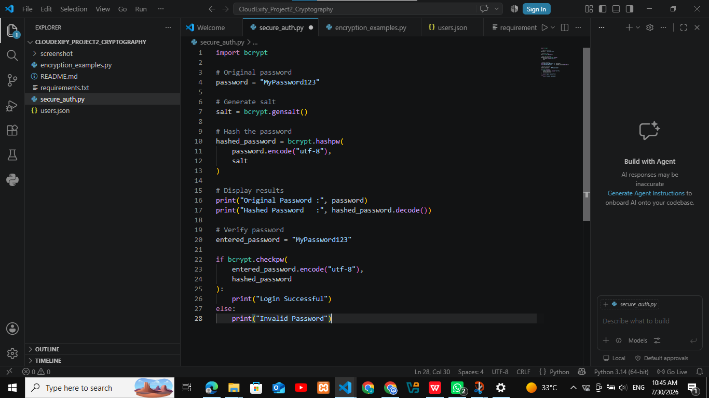

Purpose:
To implement a secure password hashing mechanism using the bcrypt algorithm in order to protect user passwords from unauthorized access and ensure they are never stored in plain-text format.

Objective:
To convert a plain-text password into a secure hashed password using the bcrypt library and demonstrate a safe password verification process during user authentication.
- Description:
The program uses the bcrypt library to securely hash a user’s password before it is stored. A unique random salt is automatically generated for each password using bcrypt.gensalt(), making every hash unique even if the same password is entered multiple times. During the login process, the entered password is verified using the bcrypt.checkpw() function, which compares the entered password with the stored hash without exposing the original password. This approach provides strong protection against brute-force attacks, rainbow table attacks, and unauthorized password disclosure.

Result:
The bcrypt hashing mechanism was successfully implemented and tested. The application securely generated unique password hashes and verified user passwords without storing or revealing the original password, demonstrating a secure and reliable password authentication process in accordance with modern cybersecurity best practices.

Terminal Output

Screen shot
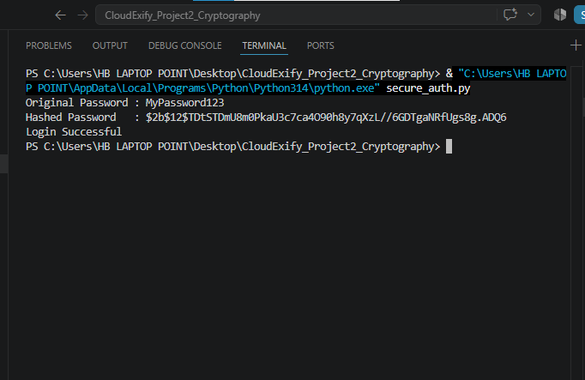

Purpose:
To verify the successful execution of the bcrypt password hashing program and ensure that the implemented password security mechanism is functioning correctly.

Objective:
To confirm that the user password is securely hashed using the bcrypt algorithm and successfully verified during the authentication process.

Description:
The terminal output displays the original password, the generated bcrypt hash, and the successful password verification result. The generated hash is different every time the program is executed because bcrypt automatically creates a unique random salt for each password. This enhances password security and protects stored credentials from common attacks.

Result:
The password was successfully hashed and verified using the bcrypt algorithm. The execution confirmed that bcrypt securely protects user passwords by generating unique hashes and providing reliable password verification without exposing the original password.

- SHA-256 vs bcrypt Comparison

Screen shot

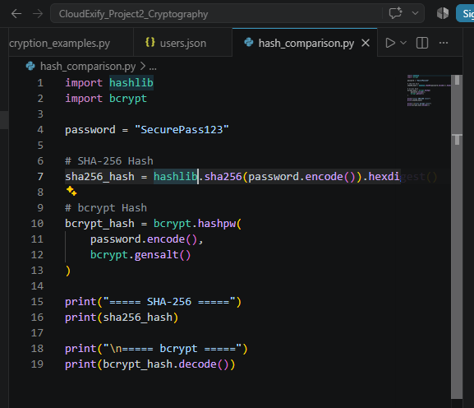

- Purpose:
To compare the SHA-256 and bcrypt hashing algorithms for password security.
- Objective:
To demonstrate the difference between traditional hashing and secure password hashing.
- Description:
The Python program generates password hashes using both SHA-256 and bcrypt. This comparison helps understand why bcrypt is the preferred algorithm for securely storing user passwords.

- Result:
The comparison program was successfully implemented and executed.

Terminal Output

Screen shot

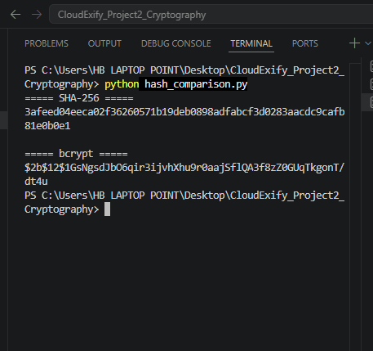

- Purpose:
To verify the output of SHA-256 and bcrypt hashing.
- Objective:
To observe how both algorithms generate hash values for the same password.
- Description:
The terminal displays the hash generated by SHA-256 and bcrypt. SHA-256 always produces the same hash for the same input, whereas bcrypt creates a different hash every time because it automatically adds a unique salt.
- Result:
The output confirms that bcrypt provides stronger password protection and is more resistant to brute-force and rainbow table attacks than SHA-256

- Comparison Table (Report)
Feature | SHA-256 | Bcrypt
Algorithm Type | Cryptographic Hash | Password Hashing
Salt Support | Manual | Automatic
Same Password Output | Same Every Time | Different Every Time
Brute Force Resistance | Low | High
Rainbow Table Protection | No | Yes
Recommended for Password Storage | No | Yes

- Fernet Encryption

Screen shot

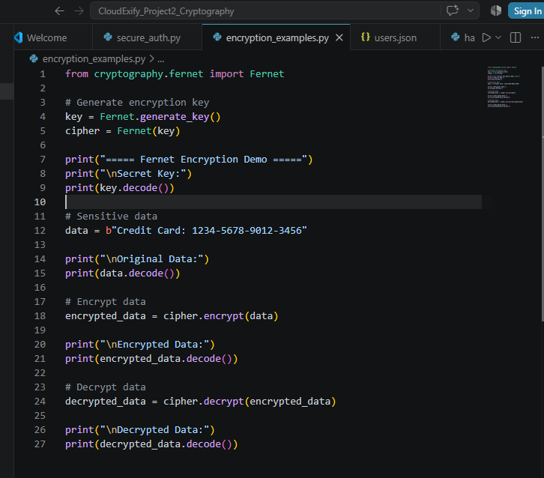

Purpose:
To implement secure data encryption and decryption using the Fernet algorithm and demonstrate how sensitive information can be protected from unauthorized access.

Objective:
To demonstrate how confidential data can be securely encrypted into ciphertext and later decrypted back to its original form using the same secret encryption key.

Description:
The program generates a unique secret key using the Fernet encryption algorithm and uses it to encrypt confidential data into an unreadable ciphertext. The same secret key is then used to decrypt the encrypted data and restore the original message. Fernet is a symmetric encryption algorithm, meaning that a single shared key is required for both encryption and decryption. This approach ensures that sensitive information remains protected and can only be accessed by authorized users who possess the correct key.

Result:
The encryption and decryption process was successfully implemented and tested. The program securely encrypted the original data and accurately recovered it using the correct secret key, demonstrating the effectiveness of the Fernet algorithm for protecting sensitive information.

Terminal Output

Screen shot

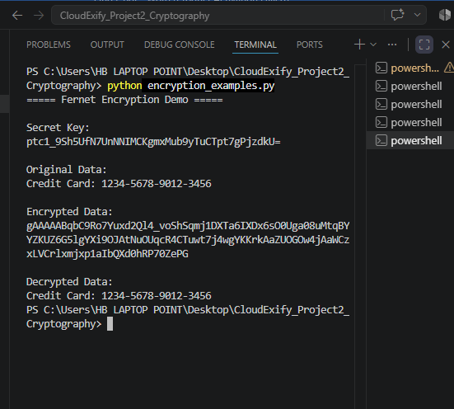
- Purpose:
To verify the successful execution of the encryption and decryption process using the Fernet algorithm and ensure that sensitive data is securely protected.
- Objective:
To confirm that confidential data can only be decrypted and recovered using the correct secret key, ensuring secure access to encrypted information.
- Description:
The terminal output displays the generated secret key, the original plaintext message, the encrypted ciphertext, and the decrypted plaintext. The encrypted data is unreadable without the secret key, while the decrypted output exactly matches the original message. This demonstrates that the Fernet algorithm successfully encrypts sensitive information and restores it accurately using the correct key, ensuring data confidentiality and integrity.
- Result:
The Fernet encryption system successfully encrypted and decrypted the sensitive data. The execution confirmed that the original information was securely protected during transmission and accurately recovered after decryption using the correct secret key.
- Wrong Key Scenario

Screenshot

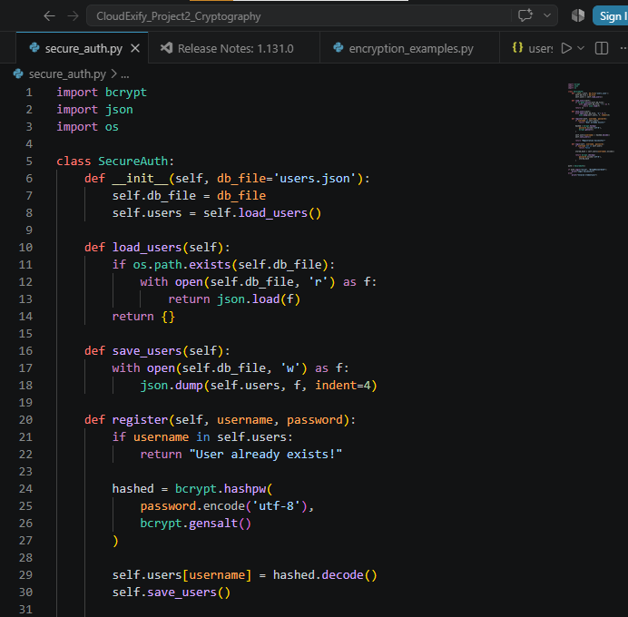

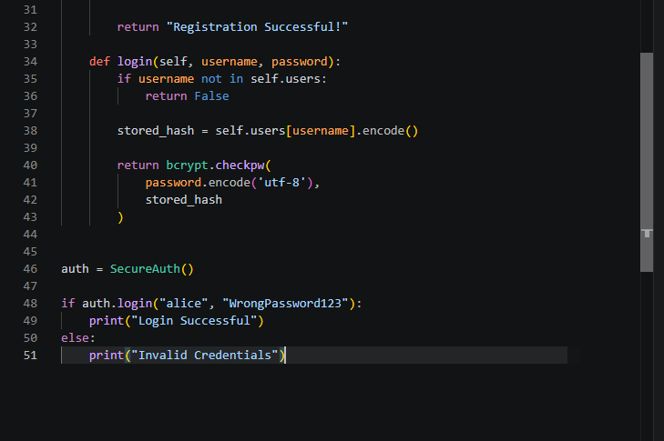
- Purpose:
To verify that the secure login system rejects an incorrect password and prevents unauthorized login.
- Objective:
To confirm that the system uses bcrypt password verification and allows authentication only when the entered password matches the stored password hash.
- Description:
An incorrect password was intentionally entered for the registered user alice. The system used bcrypt.checkpw() to compare the entered password with the securely stored bcrypt hash. Since the password did not match, the login attempt was rejected.
- Result:
- The incorrect key test confirmed that the Fernet algorithm effectively blocks unauthorized decryption attempts, providing strong confidentiality and protecting sensitive information from unauthorized access.

Terminal Output

Screen shot
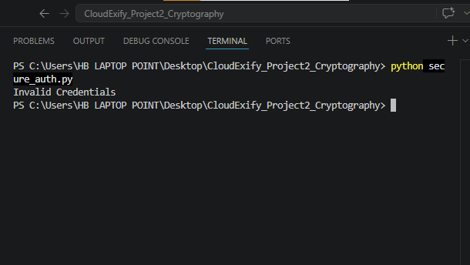
- Secure Login System

Screen shot

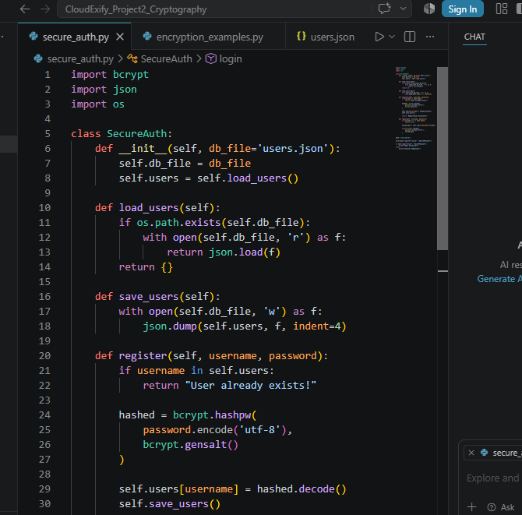

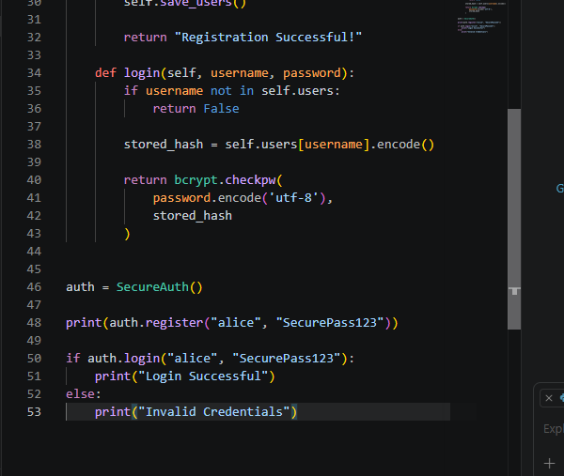
- Purpose:
To implement a secure user authentication system that protects user credentials by storing passwords in a secure hashed format instead of plain text.
- Objective:
To demonstrate the implementation of password hashing and user authentication using Python and the bcrypt library, ensuring secure registration and login functionality.
- Description:
The secure_auth.py file contains the SecureAuth class, which provides functions for user registration, secure password hashing, login verification, and JSON-based user data storage. During registration, passwords are hashed using bcrypt before being saved. During login, the entered password is verified against the stored hash, ensuring secure authentication without exposing the original password.
- Result:
The secure authentication program was successfully implemented and tested. It securely stores user credentials, verifies login attempts using hashed passwords, and is ready for execution.

- users.json

Screen shot

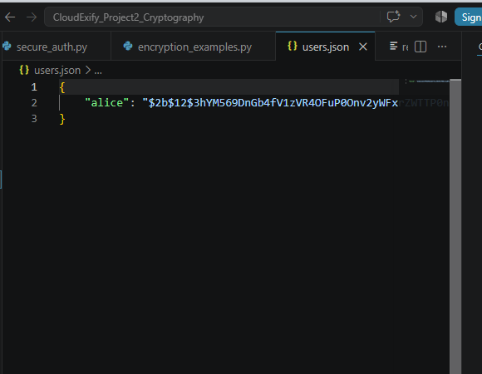

- Purpose:
To securely store user credentials by protecting passwords with strong encryption techniques instead of saving them as plain text.
- Objective:
To verify that user passwords are stored as bcrypt hashes, ensuring that sensitive information remains secure and reducing the risk of unauthorized access.
- Description:
The users.json file stores usernames along with their corresponding bcrypt hashed passwords. During registration, each password is converted into a unique hash before being saved. The original password is never stored, making it difficult for attackers to recover user credentials even if the file is accessed.
- Result:
User credentials were successfully stored in the users.json file using bcrypt hashing. The system securely protects passwords and follows good authentication security practices.

Terminal Output

Screen shot

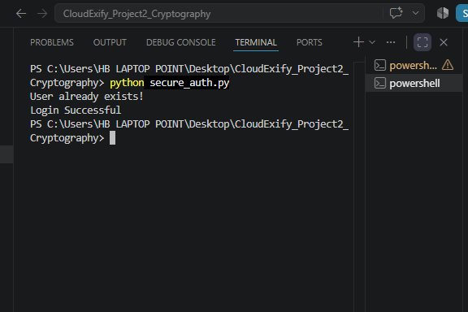

- Purpose:
To verify the successful execution of the secure authentication system and ensure that the registration and login processes work correctly.
- Objective:
To confirm that users can register successfully and log in using valid credentials after secure password verification.
- Description:
The terminal output displays the execution results of the authentication program. It shows that the user registration process was completed successfully, the password was securely hashed and stored, and the login process verified the entered password against the stored bcrypt hash. A successful login message confirms that the authentication process is functioning correctly.
- Result:
The authentication system executed successfully. User registration and login were completed
without errors, and the system securely authenticated the user using bcrypt password verification.

- HTTPS & SSL/TLS
  - Opening the Google Website for HTTPS Verification
Screenshot

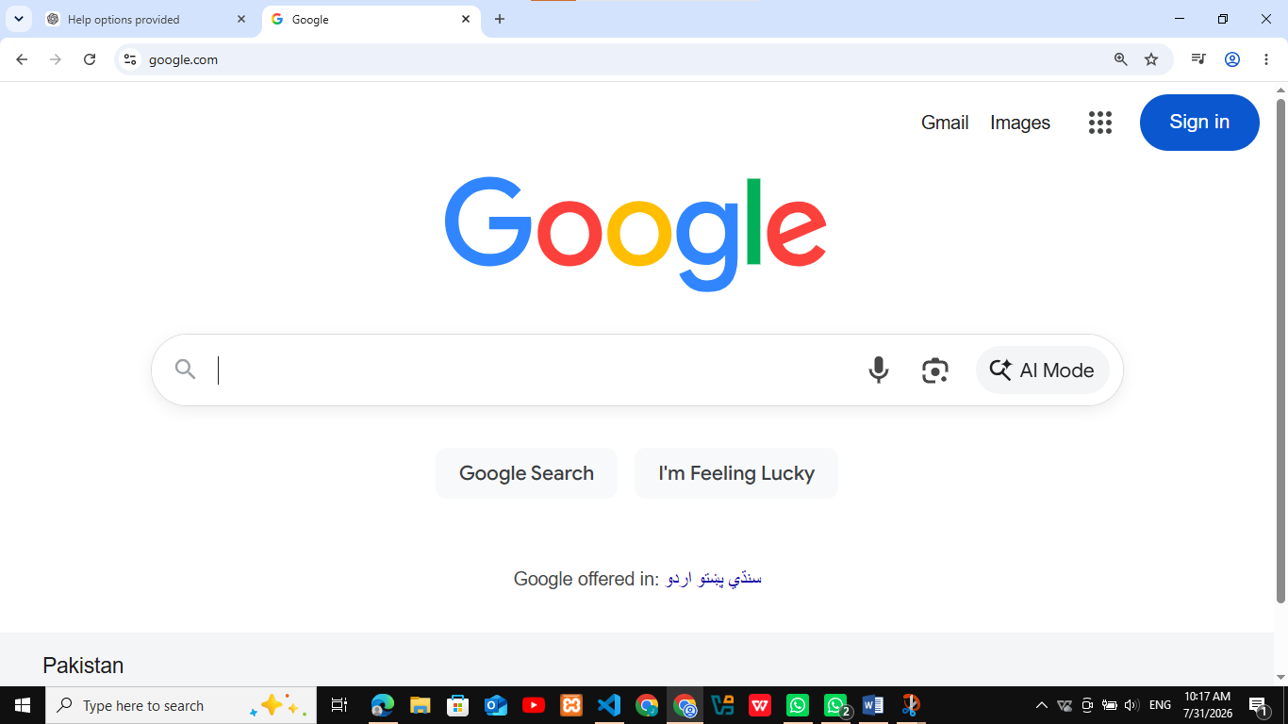
- Purpose:
To access a trusted website in order to verify the use of HTTPS and SSL/TLS security.
- Objective:
To ensure that the website establishes a secure and encrypted connection between the user's browser and the web server.
- Description:
The Google website was opened in a web browser as the first step of the HTTPS verification process. Google is a trusted website that uses the HTTPS protocol to protect data transmitted over the internet. Opening the website allows the browser to display its security information, which can then be examined to verify SSL/TLS encryption and confirm that the connection is secure.
- Result:
The Google website opened successfully and was ready for HTTPS and SSL/TLS security verification.

Verifying the Secure HTTPS Connection

Screenshot

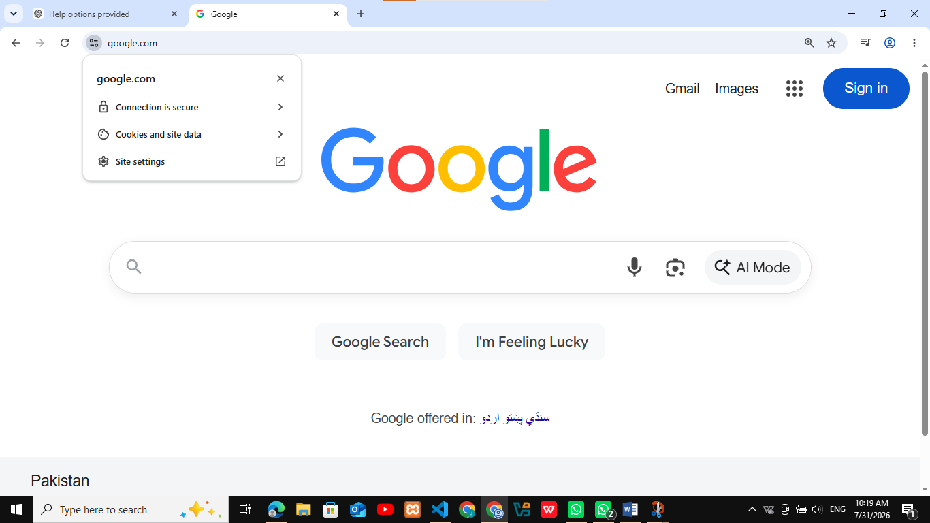
- Purpose:
To verify that the website uses a secure HTTPS connection protected by SSL/TLS encryption.
- Objective:
To confirm that the browser recognizes the website as secure and that data exchanged between the user and the website is encrypted.
- Description:
The security information of the Google website was opened by clicking the icon next to the website address in the browser. The browser displayed the message "Connection is secure", indicating that the website is using HTTPS with a valid SSL/TLS certificate. This confirms that communication between the browser and the website is encrypted, helping protect user data from unauthorized access.
- Result:
The browser successfully confirmed that the Google website uses a secure HTTPS connection with a valid SSL/TLS certificate, ensuring encrypted and secure communication.
  - Viewing the SSL/TLS Certificate Details

Screenshot
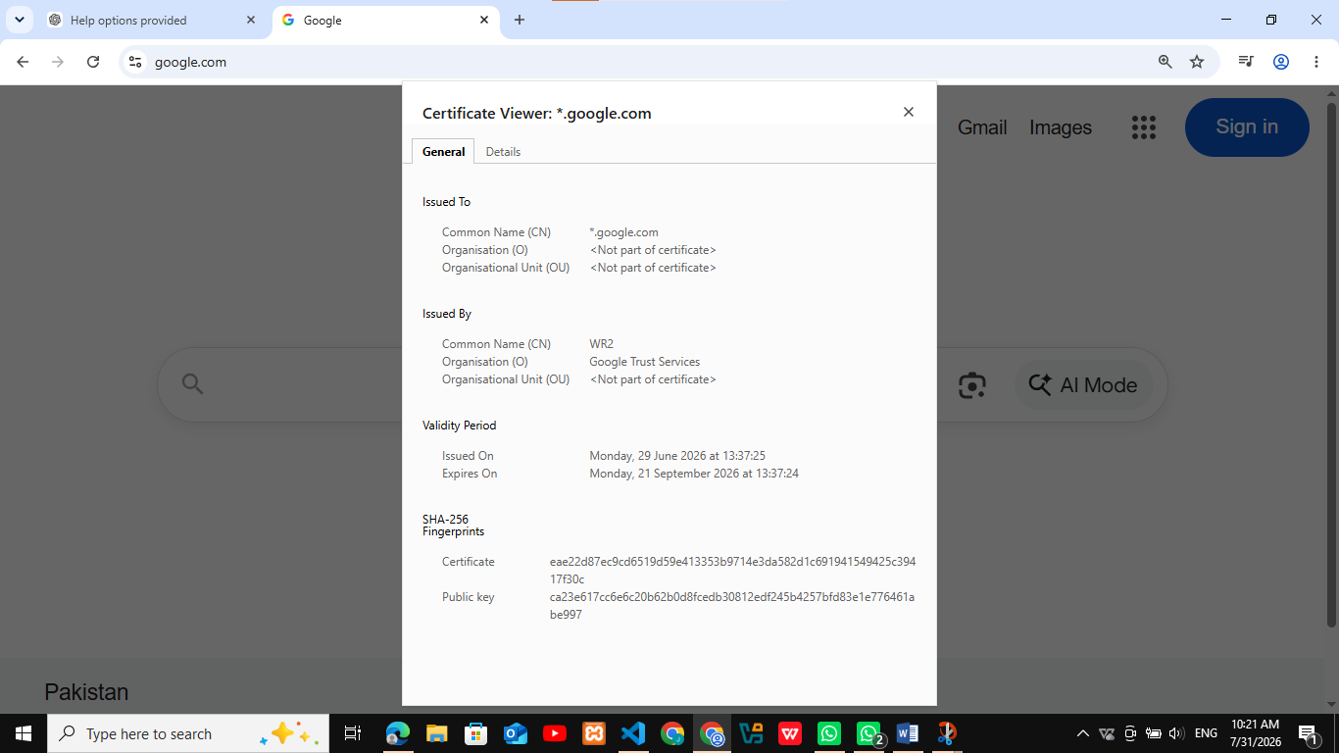
- Purpose:
To examine the digital SSL/TLS certificate used by the website.
- Objective:
To verify the certificate issuer, validity period, and other security details that confirm the authenticity of the website.
- Description:
The SSL/TLS certificate details were opened from the browser's Certificate Viewer. The certificate information displayed the common name (*.google.com), the issuing authority (Google Trust Services), the certificate validity period, and the SHA-256 fingerprint. These details confirm that the website is protected by a valid digital certificate, ensuring encrypted communication and verifying the identity of the website.
- Result:
The SSL/TLS certificate was successfully verified, confirming that the website uses a valid digital certificate for secure and encrypted communication.

- Professional Testing Table
Test Case | Expected Result | Actual Result | Status
User Registration | User registration should be successful | Registration Successful | Pass
Correct Password Login | User should log in successfully | Login Successful | Pass
Wrong Password Login | Access should be denied | Invalid Credentials | Pass
SHA-256 Hash Generation | SHA-256 hash should be generated | Hash generated successfully | Pass
bcrypt Hash Generation | Secure bcrypt hash should be generated | Hash generated successfully | Pass
Fernet Encryption | Plaintext should be encrypted | Encryption Successful | Pass
Fernet Decryption | Original plaintext should be recovered | Decryption Successful
Password Storage | Password should be stored as a bcrypt hash | Password stored securely in users.json | Pass
HTTPS Verification | Website should use HTTPS | Secure connection verified | Pass
SSL/TLS Certificate Verification | Certificate should be valid | Certificate verified successfully | Pass

Testing Summary
All project modules were tested successfully. Password hashing, user authentication, encryption/decryption, HTTPS verification, and SSL/TLS certificate validation worked as expected. The project follows cybersecurity best practices by securely storing passwords, encrypting sensitive data, and using secure communication protocols.

- Security Best Practices

Purpose
To highlight the security measures implemented in the project for protecting user credentials and sensitive information.

Objective
To demonstrate the use of cybersecurity best practices for secure authentication, password protection, and data encryption.

Description
The following security best practices were implemented in this project:
- Passwords are hashed using the bcrypt algorithm before storage.
- Plain-text passwords are never stored in the system.
- A unique salt is automatically generated for each password using bcrypt.
- Sensitive information is encrypted using the Fernet encryption algorithm.
- User credentials are stored securely in the users.json file.
- Password verification is performed securely using bcrypt.checkpw().
- HTTPS and SSL/TLS concepts were studied to understand secure communication over the internet.
- Python secure coding practices were followed to improve the overall security of the application.

Result
The project successfully follows modern cybersecurity best practices by securely storing passwords, encrypting sensitive data, and implementing a secure user authentication system.
- Best Practices Summary Table
Security Practice | Status
Password Hashing with bcrypt | Implemented
Plain Text Password Storage Avoided | Implemented
Automatic Salt Generation | Implemented
Secure Password Verification | Implemented
Fernet Data Encryption | Implemented
Secure User Data Storage | Implemented
HTTPS & SSL/TLS Understanding | Implemented
Secure Python Coding Practices | Implemented

- Challenges Faced
During the development of this project, several practical challenges were encountered. Initially, configuring the Python environment and installing the required libraries took some time. Understanding the difference between password hashing and encryption also required careful study. Managing user authentication, JSON file handling, and verifying encrypted data were additional learning experiences. These challenges were resolved through testing, debugging, and following secure coding practices.

- Learning Outcomes

Purpose
To summarize the knowledge and practical skills gained during the completion of the project.

Objective
To demonstrate the cybersecurity concepts learned through hands-on implementation.

Description
During this project, I gained practical experience in implementing password security and cryptography using Python. I learned how bcrypt securely hashes passwords, why SHA-256 is not recommended for password storage, and how Fernet encryption protects sensitive information. I also understood the importance of HTTPS and SSL/TLS in securing communication over the internet. Additionally, I improved my Python programming, debugging, file handling, and secure authentication skills.

Result
The project enhanced my practical understanding of cryptography, secure authentication, password protection, and cybersecurity best practices.

- Conclusion

Purpose
To summarize the overall achievements of the project.

Objective
To evaluate whether the project objectives were successfully achieved.

Description
This project successfully demonstrated the implementation of cryptography and password security techniques using Python. Secure password hashing was implemented with bcrypt, sensitive data was protected using Fernet encryption, and a secure user authentication system was developed. The project also explored HTTPS and SSL/TLS concepts to understand secure communication over the internet. All required functionalities were tested successfully and followed cybersecurity best practices.

Result
The project was completed successfully and met all the required objectives. It provided valuable practical experience in secure authentication, encryption, and password protection while following modern cybersecurity standards.

